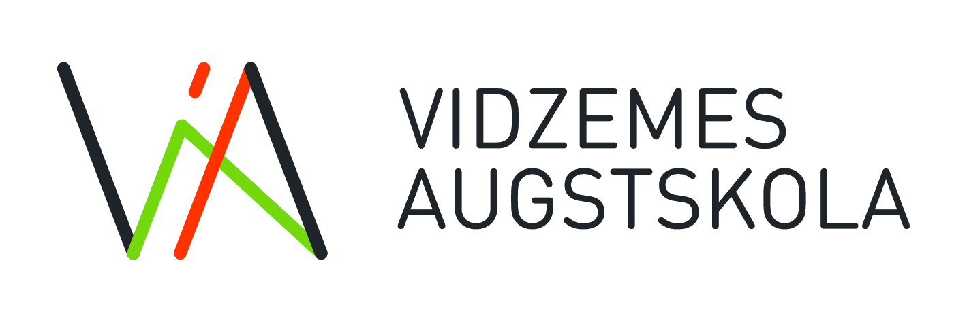

Study Direction “Communication and Media”
Application for Master’s Thesis

- Information of the applicant
Applicant’s name
Study programme | Media and Information Literacy  Strategic Communication and Governance
Date

2. Master’s thesis topic

- Introduction
  - Research problem and its substantiation (use evidence-based arguments and provide references, where appropriate), (250-300 words) – 3 points

  - Research carried out so far and knowledge explaining the choice of the research topic and its relevance (what is known, what is still not known, what are reviews of previous studies – use evidence-based knowledge and provide references), (250-300 words) – 3 points

  - Research goal – 1 point

  - Research question(s) – 2 points

- List of literature used for the preparation of the application (use both scientific monographs and scientific publications; textbooks and non-academic sources should be avoided; literature sources has to be also in a foreign language, including English; prepare a list of literature in accordance with any of reference systems) – 1 point

Please be informed that your personal data will be processed in order to evaluate the suitability of your application. The manager of personal data – Vidzeme University of Applied Sciences (hereinafter – data manager); The data manager will keep your personal data (name, last name, e-mail, evaluation) only for as long as necessary to achieve the results, which the data was supplied go for as long as stated within the normative enactments. As the subject of the data, you have the following rights: - Request the data manager the access to your (as data subject) processed personal data, ask for amendments if the data is incorrect or request for it to be deleted by submitting the reasoning for request, it is also possible to restrict the data processing as well as reject it from being processed in accordance with the rules and regulations in Latvia; - Submitted a complaint for unlawful usage of your personal data in the Data State inspection.

